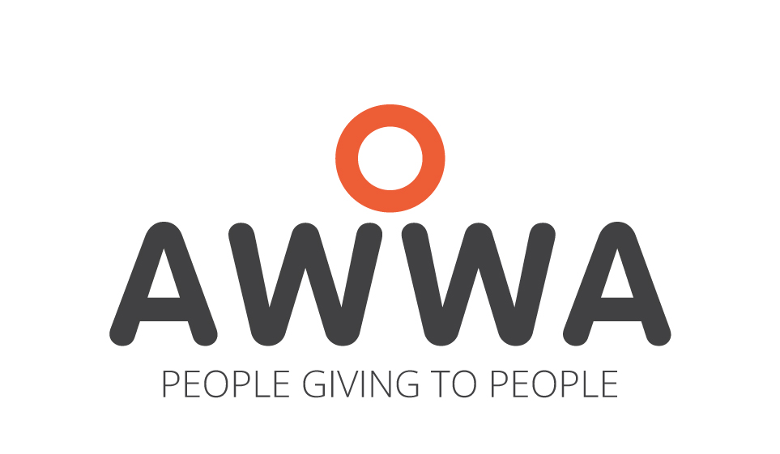
Low Vision Service Referral Form
Community Integration Service (CIS)
CIS Low Vision Service supports children with diagnosed low vision conditions (e.g. maculopathy, cone rod dystrophies, nystagmus, retinitis etc) in mainstream schools.
Based on the World Health Organization’s International Classification of Diseases (ICD-11, 2022), visual impairment is defined as the following:
- Visual acuity of 6/18 or worse in the better eye or both eyes, and/or
- Visual field of less than 10 degrees from point of fixation, and/or
- Impaired visual functioning (even after treatment and/or standard refractive correction) resulting in difficulties in the planning and executing activities requiring vision
Students with Low Vision are defined as persons who are using or can potentially use their residual vision for the planning and execution of various vision-related tasks (e.g. looking at the whiteboard to copy notes; accessing worksheets for reading or writing; moving across different school areas and terrains; performing lab practical or computer-related activities),

SECTION A: CHILD + PARENT INFORMATION & CONSENT

CHILD’S PARTICULARS
Name : ______________________________________________ Gender : Male / Female*
Date of Birth : ______________________________________________ BC No. : ______________________________
Address : ______________________________________________ Postal Code: ____________________________
Contact Number (If applicable): ______________________________________________ Nationality : ____________________________
Diagnosis /Condition : ______________________________________________ Race : ______________________________
Medical History : ______________________________________________ School : ______________________________
Assistive Device(s) Used : ______________________________________________ Class : ______________________________

PARENT’S INFORMATION
Name & Relationship : ______________________________________________ Contact : _____________________
Email : ______________________________________________ Occupation : _____________________

SOURCE OF REFERRAL
Name of referee : ______________________________________________ Designation : _____________________
Institution (if applicable) : ______________________________________________ Relationship to child : _____________________
Email : _____________________________________________ Contact Number : _____________________
Reason(s) for referring the child: [Common difficulties include – Participation in Lessons; Near/Distance Vision issues; Orientation & Mobility; Social Interactions etc]
__________________________________________________________________________________________________________________________________________________________________________________________________________________________________________________
Consent for Referral:
I _________________________________________________________ (Parent/ legal guardian), consent to the referral to CIS.
I have been informed that the Referring Agency will disclose/ transfer relevant information pertaining to me/my household to CIS.
I understand that the disclosure of such information is necessary to facilitate the referral.
I hereby give my consent for the release/ disclosure of such information to CIS to facilitate the referral.
I consent for CIS to approach the Referring Agency / Medical Professionals for relevant (medical) information required.
Signature: Date:
SECTION B: SCHOOL INFORMATION FORM
SCHOOL INFORMATION FORM
To be completed by school personnel

Name of child : ______________________________________ Age : ________________________
School : ______________________________________ Class : ________________________

Students with Low Vision often face multiple difficulties in school that not only affect their school performance, but also their mobility, social relationships, and participation in leisure and co-curricular activities. Please share with us any comments that can help us to better understand the child’s needs including:
- Vision-related issues for school activities and performance
- Orientation and Mobility issues in school environment
- Social relationship issues with peers
- Issues in AT Device use in school
________________________________________________________________________________________________________________________________________________________________________________________________________________________________________________________________________________________________________________________________
REQUEST FOR PROFESSIONAL INVOLVEMENT
Please ensure student’s diagnosis details have been entered into School Cockpit Special Education Needs (SEN) Panel before submission of this form.
School Personnel (Name/ Designation) | Signature | Date
Recommended by School Principal (Name) | Signature | Date

SECTION C: OTHER INFORMATION + RELEVANT REPORTS

Please tick if there are any other concerns regarding the student’s:
School Attendance Health/Physical Status Family Circumstances Hearing Learning/Behavioural Issues
Social Communication Emotional well-being

Other professionals working with the client? Yes / No
Name of Agency/ Hospital/ Organization : ______________________________________
Name of Professional/Optometrist/Ophthalmologist : _____________________________________
Designation in above institution : ______________________________________
(Please attach any additional information/reports that are available)
Any further information:
___________________________________________________________________________________________________________
Please ensure the following documents are in order before sending your referral form to AWWA CIS Low Vision Service:
- Personal Documents + Medical Reports:
- Child’s Birth Certificate
- Medical Report(s) from the Optometrist/Ophthalmologist

- Pupil’s Academic Performance
- Most recent CA/SA result slips

- Completed Low Vision Services Referral Form including:
- Section A: Child + Parent Information & consent
- Section B: School Information Form
- Section C: Other Information + Relevant Reports

Please return completed forms to: Programme Manager
AWWA Community Integration Service
9 Lorong Napiri
Singapore 547531
Tel: 6511-5210

OR email to: AWWA Community Integration Service
youth_disability@awwa.org.sg

